ISO 20022

Bank Account Management

Message Definition Report Part 1

Approved by the Securities SEG on 11 January 2021

This document provides information about the use of the messages for Bank Account Management and includes, for example, business transactions and examples.

February 2021

Table of Contents

Table of Contents 2

1 Introduction 3

1.1 Terms and Definitions 3

1.2 Abbreviations and Acronyms 3

1.3 Document Scope and Objectives 3

1.4 References 4

2 Scope and Functionality 5

2.1 Scope 5

2.2 Groups of MessageDefinitions and Functionality 5

3 BusinessRoles and Participants 7

3.1 Participants and BusinessRoles Definitions 7

4 BusinessProcess Description 8

5 Description of BusinessActivities 9

5.1 Opening Process Activity Diagram 9

5.2 Maintenance Process Activity Diagram 10

5.3 Closing Process Activity Diagram 11

5.4 Reporting Process Activity Diagram 12

6 BusinessTransactions 13

6.1 Account Opening Process 13

6.2 Account Maintenance Process 17

6.3 Account Closing Process 21

Revision Record 26

Preliminary Note

The Message Definition Report (MDR) is made of three parts:

MDR Part 1

This describes the contextual background required to understand the functionality of the proposed message set. Part 1 is produced by the submitting organisation that developed or maintained the message set in line with an MDR Part 1 template provided by the ISO 20022 Registration Authority (RA) on [www.iso20022.org](http://www.iso20022.org).

MDR Part 2

This is the detailed description of each message definition of the message set. Part 2 is produced by the RA using the model developed by the submitting organisation.

MDR Part 3

This is an extract if the ISO 20022 Business Model describing the business concepts used in the message set. Part 3 is an Excel document produced by the RA

# Introduction

## Terms and Definitions

The following terms are reserved words defined in ISO 20022 Edition 2013 – Part1. When used in this document, the UpperCamelCase notation is followed.

|  |  |
| --- | --- |
| Term | Definition |
| BusinessRole | Functional role played by a business actor in a particular BusinessProcess or BusinessTransaction. |
| Participant | Involvement of a BusinessRole in a BusinessTransaction. |
| BusinessProcess | Definition of the business activities undertaken by BusinessRoles within a BusinessArea whereby each BusinessProcess fulfils one type of business activity and whereby a BusinessProcess may include and extend other BusinessProcesses. |
| BusinessTransaction | Particular solution that meets the communication requirements and the interaction requirements of a particular BusinessProcess and BusinessArea. |
| MessageDefinition | Formal description of the structure of a message instance. |

1. When a MessageDefinition or message identifier is specified, it should include the variant and version number. However, in this document (except in the business examples section, if present), variant and version numbers are not included. In order to know the correct variant and version number for a MessageDefinition, the related Message Definition Report Part 2 document should be consulted.

## Abbreviations and Acronyms

The following is a list of abbreviations and acronyms used in the document.

|  |  |
| --- | --- |
| Abbreviation/Acronyms | Definition |
| BAM | Bank Account Management |
| MDR | Message Definition Report |

## Document Scope and Objectives

This document is the first part of the Bank Account Management Message Definition Report (MDR) that describes the BusinessTransactions and underlying message set. For the sake of completeness, the document may also describe BusinessActivities that are not in the scope of the business processes covered in this document.

This document describes the following:

* the BusinessProcess scope
* the BusinessRoles involved in these BusinessProcesses

The main objectives of this document are as follows:

* to provide information about the messages that support the business processes
* to explain the BusinessProcesses and BusinessActivities these messages have addressed
* to give a high level description of BusinessProcesses and the associated BusinessRoles
* to document the BusinessTransactions
* to provide business examples

The messages definitions are specified in Message Definition Report Part 2.

## References

|  |  |  |  |
| --- | --- | --- | --- |
| Document | Version | Date | Author |
| ISO 20022 Business Justification – Bank Account Management |  | 2010-04-27 | SWIFT |
| ISO 20022 Maintenance Change Request (MCR #170) document (Payments Maintenance 2020/2021) | 2020 | 2020-08-31 | SWIFT |

# Scope and Functionality

This Message Definition Report covers a set of 15 candidate ISO 20022 MessageDefinitions developed by SWIFT in close collaboration with CITI, RBS, UniCredit, BNPP, SocGen, Nordea, Wells Fargo, HSBC, Deutsche Bank, DBNOR, BAML, BNYM, JP Morgan Chase and submitted for approval to the Payments Standards Evaluation Group (SEG). These messages are specifically designed to support bank account management functions between a financial institution and its customer.

## Scope

As described in the ISO 20022 Business Justification, the scope covers the following communication flows: bank account opening, maintenance, closing and reporting as part of these activities.

There are two important points to understand these messages:

In many cases, the financial institution will require additional documentation that is available as PDF or Word document. The recommended solution is to group one BAM message (for example the account opening request) with these accompanying documents in one file archive. The archive establishes the link between the different documents.

Every BAM message has an optional block, at the end, meant to contain a digital signature(s). The usage of not of this signature block is to be decided as part of a specific implementation. Detailed guidelines and documentation exist to explain how to sign the whole of a BAM message, or a part of it, or even have multiple signatures.

## Groups of MessageDefinitions and Functionality

1. These messages are to be used without the ISO 20022 Business Application Header (head.001). The schema and more information about the Business Application Header (BAH) can be found on the www.iso20022.org web site

### Groups

#### Account Opening

|  |  |
| --- | --- |
| MessageDefinition | Message Identifier |
| AccountOpeningRequest | acmt.007 |
| AccountOpeningAmendmentRequest | acmt.008 |
| AccountOpeningAdditionalInformationRequest | acmt.009 |

#### Reports and Miscellaneous

|  |  |
| --- | --- |
| MessageDefinition | Message Identifier |
| AccountRequestAcknowledgement | acmt.010 |
| AccountRequestRejection | acmt.011 |
| AccountAdditionalInformationRequest | acmt.012 |
| AccountReportRequest | acmt.013 |
| AccountReport | acmt.014 |

#### Account Maintenance

|  |  |
| --- | --- |
| MessageDefinition | Message Identifier |
| AccountExcludedMandateMaintenanceRequest | acmt.015 |
| AccountExcludedMandateMaintenanceAmendmentRequest | acmt.016 |
| AccountMandateMaintenanceRequest | acmt.017 |
| AccountMandateMaintenanceAmendmentRequest | acmt.018 |

#### Account Closing

|  |  |
| --- | --- |
| MessageDefinition | Message Identifier |
| Account ClosingRequest | acmt.019 |
| AccountClosingAmendmentRequest | acmt.030 |
| AccountClosingAdditionalInformationRequest | acmt.031 |

### Functionality

See Message Definition Report Part 2 for the message scopes and formats.

# BusinessRoles and Participants

A BusinessRole represents an entity (or a class of entities) of the real world, physical or legal, a person, a group of persons, a corporation. Examples of BusinessRoles: “Financial Institution”, “Automated Clearing House”, “Central Securities Depository”.

A Participant is a functional role performed by a BusinessRole in a particular BusinessProcess or BusinessTransaction. Examples of Participants: the “user” of a system, “debtor”, “creditor”, “investor”.

The relationship between BusinessRoles and Participants is many-to-many. One BusinessRole can be involved as different Participants at different moments in time or at the same time. Examples of BusinessRoles: "user", "debtor”, "creditor", "investor". Different BusinessRoles can be involved as the same Participant.

## Participants and BusinessRoles Definitions

Participants

| Description | Definition |
| --- | --- |
| Account Servicer | Party that manages the account on behalf of the account owner (that is, manages the registration and booking of entries on the account, calculates balances on the account and provides information about the account), or the party that has a contractual relationship with the owner. |
| Account Owner | Party that legally holds the account or the party in a contractual relationship with the servicer. |

# BusinessProcess Description

This diagram represents the high level BusinessProcesses.

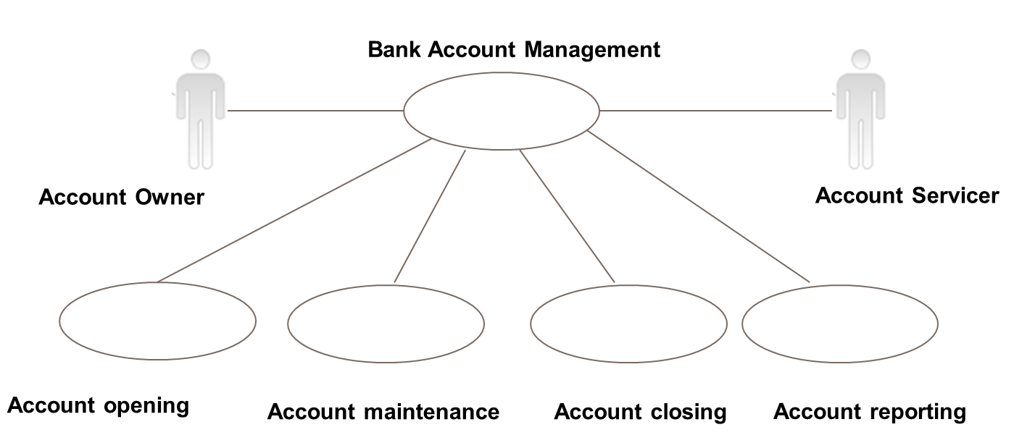

# Description of BusinessActivities

This section presents the different BusinessActivities within each BusinessProcess. The BusinessActivities of a process are described with activity diagrams.

Legend

|  |  |  |
| --- | --- | --- |
| Symbol | Name | Definition |
|  | Start Point | Shows where the lifecycle of the business process commences. |
|  | End Point | Shows where the lifecycle of the business process may ends. |
|  | Lozenge (or diamond) | Indicates that a choice between several actions can be made. |
|  | Bar | Indicates that several actions are initiated in parallel. |

## Opening Process Activity Diagram

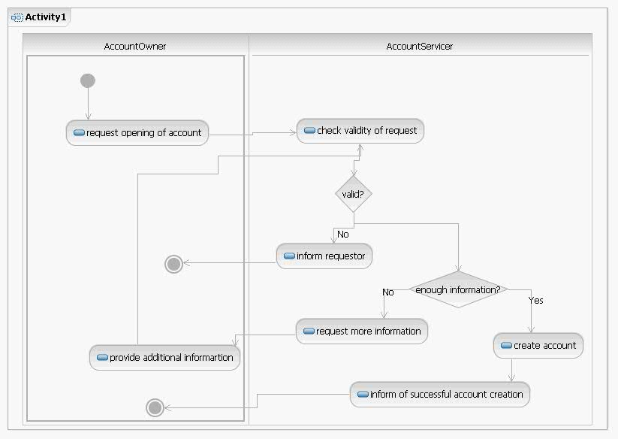

| Descriptions of the activities | |
| --- | --- |
|  | Initiator |
| Request opening of account | Account Owner |
| Check validity of request | Account Servicer |
| Inform requestor | Account Servicer |
| Request more information | Account Servicer |
| Provide additional information | Account Owner |
| Create account | Account Servicer |
| Inform of successful creation of account | Account Servicer |

## Maintenance Process Activity Diagram

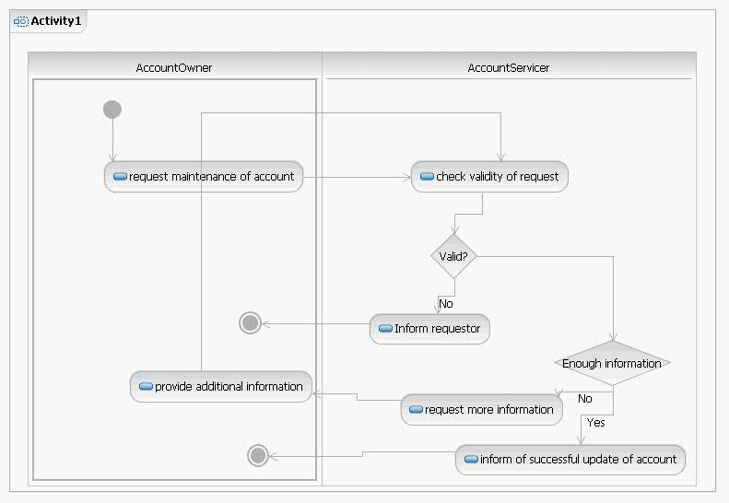

| Descriptions of the activities | |
| --- | --- |
|  | Initiator |
| Request maintenance of account | Account Owner |
| Check validity of request | Account Servicer |
| Inform requestor | Account Servicer |
| Request more information | Account Servicer |
| Provide additional information | Account Owner |
| Inform of successful update of account | Account Servicer |

## Closing Process Activity Diagram

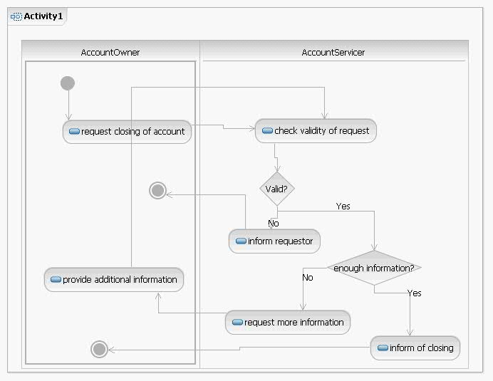

| Descriptions of the activities | |
| --- | --- |
|  | Initiator |
| Request closing of account | Account Owner |
| Check validity of request | Account Servicer |
| Inform requestor | Account Servicer |
| Request more information | Account Servicer |
| Provide additional information | Account Owner |
| Inform of closing of account | Account Servicer |

## Reporting Process Activity Diagram

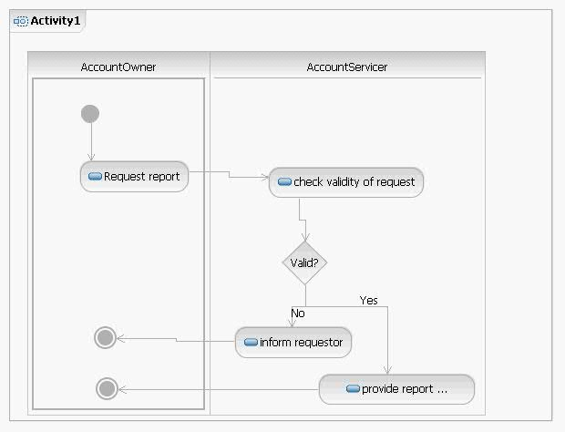

| Descriptions of the activities | |
| --- | --- |
|  | Initiator |
| Request report | Account Owner |
| Check validity of request | Account Servicer |
| Inform requestor | Account Servicer |
| Provide report | Account Servicer |

# BusinessTransactions

This section describes the message flows based on the activity diagrams documented above. It shows the typical exchanges of information in the context of a BusinessTransaction.

## Account Opening Process

### Straight opening process

Short description: This scenario is the basic and most elementary scenario for opening a bank account. The organisation decides to open a new bank account and sends an AccountOpeningRequest message. The received message is checked for authentication and authorisation. When these two checks are passed the financial institution sends an AccountRequestAcknowledgement message to the organisation as a confirmation of a message receipt. The financial institution continues to process the opening request by analysing the account details. When this is complete, the financial institution registers the account with all details in its back office. The AccountReport message is sent by the financial institution to inform the organisation about the registration of the new bank account. This AccountReport message can be used by the organisation to verify the details of the account compared to the original request.

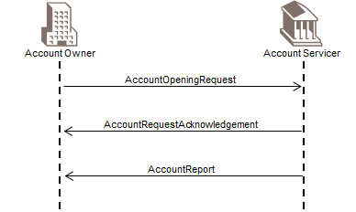

[1] The organisation sends an AccountOpeningRequest message to the financial institution. The organisation specifies in the message all the known details related to the account to be opened.

[2] The financial institution sends an AccountRequestAcknowledgement message back to the organisation. This message contains the acknowledgement of the received account opening message and possibly a reserved account number.

[3] When the account is completely defined, the financial institution sends an AccountReport message with the actual setup of the account. By doing this the organisation is informed about the setup of the account and can compare the account characteristics to the initial request.

### Authentication or authorisation errors during the account opening process

Short description: The organisation sends an AccountOpeningRequest message to the financial institution. The received message is checked for authentication and authorisation. During the authentication or authorisation process an error can occur, for example, authentication of the sender or checking the authorisation of the sending person generates an error. To avoid any further security issues during the opening process the financial institution doesn’t reply automatically to the sender. By not responding, the possible fraudulent sender is not informed. Instead, the financial institution informs the organisation by phone about the authentication/authorisation issue. The organisation can send a new message for opening a bank account. The account opening process restarts all over.

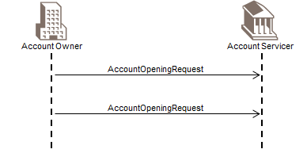

[1] The organisation sends an AccountOpeningRequest message to the financial institution. The organisation specifies in the AccountOpeningRequest message all the known details related to the account to be opened. During the analysis of the AccountOpeningRequest message an error occurs on the authentication or authorisation.

[2] The relationship manager or the customer account management department contacts the organisation by phone to inform them about the security issue. The purpose is that no automatic reply message will be generated towards the sender of the original AccountOpeningRequest message.

[3] When the organisation is informed about the problem, the decision can be taken to restart the account opening process by resending a new AccountOpeningRequest message.

### Account opening with rejection

Short description: The organisation sends an AccountOpeningRequest message to the financial institution. The received message is checked for authentication and authorisation. When these two checks are passed the financial institution sends an AccountRequestAcknowledgement message to the organisation as a confirmation of a valid message receipt. This AccountRequestAcknowledgement message can contain the new allocated account number. The organisation should wait for the AccountReport message that will signal the end of the process.

The financial institution continues to process the request by analysing the account details. If during this analysis and verification an error occurs, an AccountRequestRejection message will be sent by the financial institution. The organisation will react upon this AccountRequestRejection message by sending an AccountOpeningRequest message.

When the analysis of the AccountOpeningRequest message successfully ends, the financial institution registers the account and the account details in its back office. The AccountReport message is sent by the financial institution to inform the organisation about the registration of the new bank account. This AccountReport message can be used by the organisation to verify the details of the account compared to the original request.

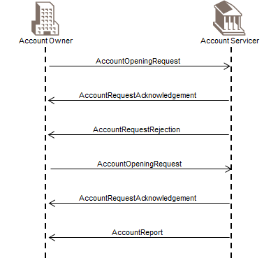

[1] The organisation sends an AccountOpeningRequest message to the financial institution. The organisation stipulates in the AccountOpeningRequest message all the known details related to account to be opened.

[2] The financial institution sends an AccountRequestAcknowledgement message back to the organisation. This message contains the acknowledgement of the received account opening message and possibly the reserved account number.

[3] The financial institution verifies the AccountOpeningRequest message. In case of error (different from authentication or authorisation) during this verification the financial institution sends an AccountRequestRejection message to inform the organisation that the opening request was rejected.

[4] The organisation verifies the AccountRequestRejection message and sends a new version of the AccountOpeningRequest message.

[5] The financial institution sends an AccountRequestAcknowledgement message back to the organisation. This message contains the acknowledgement of the received account opening message and possibly the reserved account number.

[6] When the account is completely defined, the financial institution sends an AccountReport message with the actual setup of the account. By doing this the organisation is informed about the setup of the account and can verify the account characteristics with what was sent to the financial institution.

### Account opening with a request from the financial institution for additional information

Short description: The organisation sends an AccountOpeningRequest message to the financial institution. The received AccountOpeningRequest message is checked for authentication and authorisation. When these two checks are passed the financial institution sends an AccountRequestAcknowledgement message to the organisation as a confirmation of a valid message receipt. This AccountRequestAcknowledgement message may contain the newly allocated account number. After this the financial institution continues to process the opening request by analysing the account details. It is possible that in this phase of the opening process a need for additional information arises.

To obtain the missing information, the financial institution has to send an AccountOpeningAdditionalInformationRequest message. This message is sent to the organisation to request additional information on the account. It is essential to specify the account number about which additional information is requested.

The organisation responds to this information request with an AccountOpeningAmendmentRequest message. The financial institution starts with the validation of the authentication and authorisation of the AccountOpeningAmendmentRequest message. When this validation is passed the financial institution continues to process the request by analysing the account details.

When the analysis of the AccountOpeningAmendmentRequest message is successful, the financial institution registers the account and the account details in its back office. The AccountReport message is sent by the financial institution to inform the organisation about the registration of the new bank account. This AccountReport message can be used by the organisation to verify the details of the account compared to the original request.

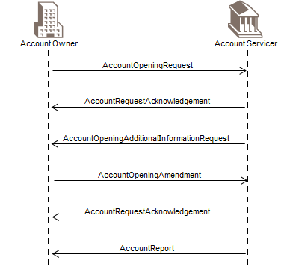

[1] The organisation sends an AccountOpeningRequest message to the financial institution. The organisation specifies in the message all the known details related to account to be opened.

[2] The financial institution sends an AccountRequestAcknowledgement message back to the organisation. This message contains the acknowledgement of the received account opening message and possibly the reserved account number.

[3] The financial institution needs additional information on the account being opened. An AccountOpeningAdditionalInformationRequest message is sent to the organisation to request the information.

[4] The organisation responds to the additional information request with an AccountOpeningAmendmentRequest message. The financial institution verifies the AccountOpeningAmendmentRequest message.

[5] If the message passes the authentication and authorisation checks, the financial institution sends an AccountRequestAcknowledgement message back to the organisation.

[6] When the account is completely defined, the financial institution sends an AccountReport message with the actual setup of the account. By doing this, the organisation is informed about the setup of the account and can verify the account characteristics with what was sent to the financial institution.

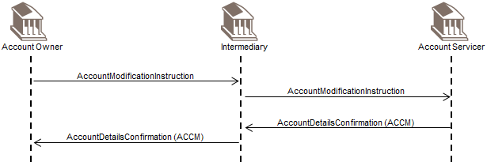

## Account Maintenance Process

### Simple maintenance process

Short description: This scenario is the basic and most elementary scenario for maintaining the non-mandate related financial institution account details. The organisation decides to update a cash account and sends an AccountExcludedMandateMaintenanceRequest message. The message is received by the financial institution, and verified for authentication and authorisation. When these two checks are valid, the financial institution sends an AccountRequestAcknowledgement message to the organisation as a confirmation of the validity of the message. The financial institution continues to handle the maintenance request by analysing all the non-mandate related details. When this is over, the financial institution can update the account and the account details in its back office. The AccountReport message is sent by the financial institution to inform the organisation about the successful update of the cash account details in the back-office. This AccountReport message can be used by the organisation to verify the details compared with the original request.

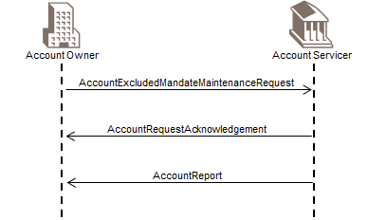

[1] The organisation sends an AccountExcludedMandateMaintenanceRequest message to the financial institution. The organisation specifies in it all the known details related to the account, to be updated.

[2] The financial institution sends an AccountRequestAcknowledgement message back to the organisation. This message is the acknowledgement of the AccountExcludedMandateMaintenanceRequest message.

[3] When the account is completely updated within the financial institution, the financial institution sends an AccountReport message with the actual set-up of the account. By doing this, the organisation is informed about the new set-up of the account and can verify the account characteristics with what was sent earlier to the financial institution.

### Errors during authentication or authorisation phase of the account maintenance process

Short description: The organisation sends an AccountExcludedMandateMaintenanceRequest message to the financial institution. The message is received by the financial institution, and verified for authentication and authorisation. During the authentication or authorisation process, a problem is detected, e.g. authentication of the sender or checking the authorisation of the sender fails. To avoid any further security issues during the maintenance process, the financial institution doesn’t reply automatically to the sender. By not responding the possible fraudulent sender is not informed. Instead, the financial institution informs the organisation by phone about the authentication/authorisation issue. The organisation can send a new message for maintaining a financial institution account. The account maintenance process restarts from the beginning.

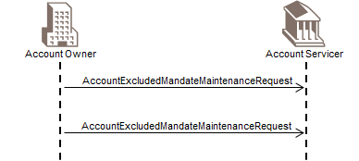

[1] The organisation sends an AccountExcludedMandateMaintenanceRequest message to the financial institution. The organisation specifies in it all the known details related to the account to be updated. During the verification of the AccountExcludedMandateMaintenanceRequest an error occurs with the authentication or authorisation.

[2] The Client Account Department contacts the organisation by phone to inform them about the security issue. The goal is that no automatic response is sent to the sender of the initial AccountExcludedMandateMaintenanceRequest message.

[3] The organisation is informed about the problem, and the decision can be taken to restart the account maintenance process by sending a new AccountExcludedMandateMaintenanceRequest message.

### Account maintenance scenario with additional information request and with rejection

Short description: The organisation sends an AccountExcludedMandateMaintenanceRequest message to the financial institution. The received message is checked by the financial institution on authentication and authorisation. When these two checks are passed, the financial institution sends an AccountRequestAcknowledgement message to the organisation as a confirmation of a valid message receipt. In this scenario, the financial institution needs more information and requests it by sending an AccountAdditionalInformationRequest.

The AccountAdditionalInformationRequest is sent to inform the financial institution to provide additional information. The modified or additional information can be any data related to the account number, except mandate or mandate holder(s) related data. The financial institution starts with the validation of the authentication and authorisation of the AccountAdditionalInformationRequest. When this validation is successful the financial institution continues to handle the request by analysing all the information details. If during this analysis and verification an error occurs, an AccountRequestRejection message will be sent by the financial institution. The organisation will react upon this AccountRequestRejection by sending a new AccountAdditionalInformationRequest message.

When this validation is successful, the financial institution continues to process the request by analysing all the account details. The financial institution sends an AccountRequestAcknowledgement message to the organisation as a confirmation of a valid message receipt. If this analysis ends successfully, the financial institution can update the account and the account details in its back office. The AccountReport message is sent by the financial institution to inform the organisation about the update of the cash account in the financial institution’s back-office. This AccountReport can be used by the organisation to verify the details compared with the original request.

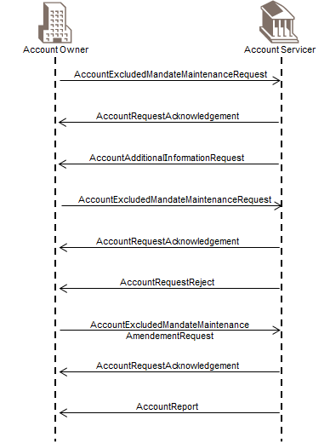

[1] The organisation sends an AccountExcludedMandateMaintenanceRequest message to the financial institution. The organisation specifies in the message all the known details related to the account to be maintained.

[2] The financial institution sends an AccountRequestAcknowledgement message back to the organisation. This message contains the acknowledgement of the received account excluded mandate maintenance message.

[3] The financial institution needs more information and requests it by sending an AccountAdditionalInformationRequest.

[4] The organisation provides additional information by sending an AccountExcludedMandateMaintenanceAmendmentRequest message to the financial institution. The organisation can do this by adding additional information, changing information already sent or deleting information components. The message has to contain the new setup of the account.

[5] The financial institution verifies the AccountExcludedMandateMaintenanceAmendmentRequest message. In case an error (different from authentication or authorisation) occurs during this verification, the financial institution sends an AccountRequestRejection message to inform the organisation that the amendment request was rejected.

[6] The organisation corrects the maintenance message by sending a new AccountExcludedMandateMaintenanceAmendmentRequest messageto the financial institution. The organisation can do this by adding additional information, changing information already sent or deleting information components. The message has to contain the new setup of the account.

[7] The financial institution sends an AccountRequestAcknowledgement message back to the organisation.

[8] When the account is defined completely in the financial institution, the financial institution sends an AccountReport message with the actual setup of the account. By doing this the organisation is informed about the setup of the account and can compare the account characteristics with what was sent to the financial institution.

1. Exactly the same message flows apply for the maintenance of mandates. The corresponding messages are: AccountExcludedMandateMaintenanceAmendmentRequest 🡪 AccountMandateMaintenanceAmendmentRequest and AccountExcludedMandateMaintenanceRequest 🡪 AccountMandateMaintenanceRequest

## Account Closing Process

### Simple closing process

Short description: This scenario is the basic and most elementary scenario for closing a bank account. The organisation decides to close a bank account and sends an AccountClosingRequest message. The received message is checked for authentication and authorisation. When these two checks are passed, the financial institution sends an AccountRequestAcknowledgement message to the organisation as a confirmation of a valid message receipt. The financial institution continues to process the closing request by analysing all the information. When this analysis ends successfully, the financial institution can close the account and the account components in its back office. The AccountReport message is sent by the financial institution to inform the organisation about the closure of the bank account. This AccountReport can be used by the organisation to verify the details compared with the original request.

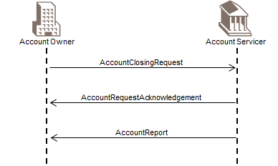

[1] The organisation sends an AccountClosingRequest message to the financial institution. The organisation specifies in the message the identification of the account to be closed.

[2] The financial institution sends an AccountRequestAcknowledgement message back to the organisation. This message contains the acknowledgement of the received account closing message.

[3] When the account is completely closed within the financial institution, the financial institution sends an AccountReport message with the actual closure of the account. By doing this the organisation is informed about the closure of the account and can compare the account closure information to the initial request.

### Errors during authentication or authorisation phase of the account closing process

Short description: The organisation sends an AccountClosingRequest message to the financial institution. The received message is verified on authentication and authorisation. During the authentication or authorisation process an error can occur, e.g. authentication of the sender or checking the authorisation of the sending person generates an error. These kinds of errors can happen during an attempt of fraudulently closing an account. To avoid any further security issues during the closing process the financial institution doesn’t reply automatically to the sender. By not responding the possible fraudulent sender is not informed. Instead, the financial institution informs the organisation by phone about the authentication/authorisation issue. The organisation can send a new message for closing a bank account. The account closing process restarts all over.

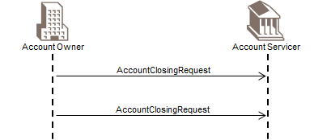

[1] The organisation sends an AccountClosingRequest message to the financial institution. The organisation stipulates in the message all the identifying details related to the account to be closed. During the analysis of the AccountClosingRequest message an error occurs on the authentication or authorisation.

[2] The relationship manager or the Customer Account Management Department contacts the organisation by phone to inform them about the security issue. The goal is that no automatic message response is generated towards the sender of the original AccountClosingRequest message.

[3] When the organisation is informed about the problem the decision can be taken to restart the account closing process by resending a new AccountClosingRequest.

### Account closing with error in the amendment request

Short description: The organisation sends an AccountClosingRequest message to the financial institution. The received message is verified by the financial institution on authentication and authorisation. When these two checks are valid the financial institution sends an AccountRequestAcknowledgement message to the organisation as a confirmation of a valid message receipt. This AccountRequestAcknowledgement can contain the new allocated account number. The organisation can react on the received message by sending an AccountClosingAmendmentRequest message.

The AccountClosingAmendmentRequest message is sent to inform the financial institution on modifications of the data of the original AccountClosingRequest or to add additional information. This additional information can be data to identify the mandate holder(s) related to the new account number. The financial institution starts with the validation of the authentication and authorisation of the AccountClosingAmendmentRequest. When this validation is correct the financial institution continues to treat the request by analysing all the information components. If during this analysis and verification an error occurs, an AccountRequestRejection message will be sent by the financial institution. The organisation will react upon this AccountRequestRejection by sending a new AccountClosingAmendmentRequest message.

When the analysis of the AccountClosingAmendmentRequest message successfully ends, the financial institution can register the account and the account components in its back office databases. The AccountReport message is sent by the financial institution to inform the organisation about the registration of the new account. This AccountReport message can be used by the organisation to verify the setup in the financial institution with the original request.

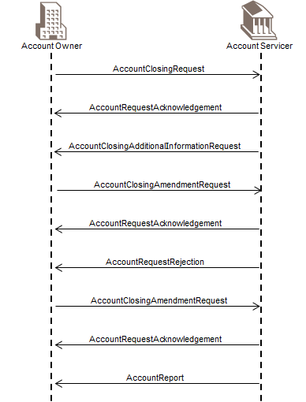

[1] The organisation sends an AccountClosingRequest message to the financial institution. The organisation specifies in the message the details related to account to be closed and transfer account.

[2] The financial institution sends an AccountRequestAcknowledgement message back to the organisation. This message contains the acknowledgement of the received account closing message.

[3] The financial institution needs more information and therefore sends an AccountClosingAdditionalInformationRequest message to the organisation.

[4] The organisation provides more information by sending an AccountClosingAmendmentRequest message to the financial institution. The organisation can do this by adding additional information, changing information already sent or deleting information components.

[5] The financial institution sends an AccountRequestAcknowledgement message back to the organisation.

[6] The financial institution verifies the AccountClosingAmendmentRequest. In case an error (different from authentication or authorisation) occurs during this verification the financial institution sends an AccountRequestRejection message to inform the organisation that the Amendment Request was rejected.

[7] The organisation verifies the AccountRequestRejection and updates the Closing Amendment request. This new version of the AccountClosingAmendmentRequest message is sent to the financial institution.

[8] The financial institution sends an AccountRequestAcknowledgement message back to the organisation.

[9] When the account is defined completely in the financial institution, the financial institution sends an AccountReport message with the actual setup of the account. By doing this the organisation is informed about the setup of the account and can verify the account characteristics with what was sent to the financial institution.

### Account closing with a request from the financial institution for additional information

Short description: The organisation sends an AccountClosingRequest message to the financial institution. The received message is checked by the financial institution on authentication and authorisation. When these two checks are passed the financial institution sends an AccountRequestAcknowledgement message to the organisation as a confirmation of a valid message receipt. This AccountRequestAcknowledgement can contain the new allocated account number. After this the financial institution continues to process the closing request by analysing all the information components. It is possible that in this phase of the closing process the need for additional information arises.

To collect the missing information, the financial institution has to send an AccountClosingAdditionalInformationRequest message. The message is sent to the organisation to request additional information of the account. It is essential to specify the account number on which additional information is requested or to what closing process it is related.

The organisation responds on this information request with an AccountClosingAmendmentRequest message. The financial institution starts with the validation of the authentication and authorisation of the AccountClosingAmendmentRequest message. When this validation is correct the financial institution continues to treat the request by analysing all the information.

When the analysis of the AccountClosingAmendmentRequest successfully ends, the financial institution can close the account in its back office. The AccountReport message is sent by the financial institution to inform the organisation about the closure of the bank account. This AccountReport message can be used by the Organisation to verify the setup with the original request.

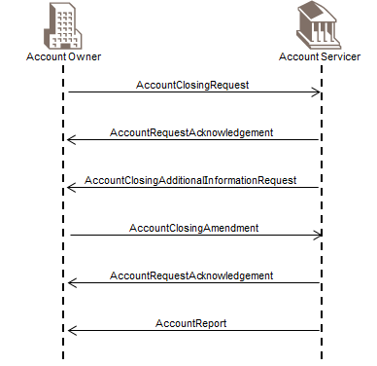

[1] The organisation sends an AccountClosingRequest message to the financial institution. The organisation stipulates in the message all the known details related to account to be closed.

[2] The financial institution sends an AccountRequestAcknowledgement message back to the organisation. This message contains the acknowledgement of the received account closing message.

[3] The financial institution needs additional information on the account being closed. An AccountClosingAdditionalInformationRequest message is sent to the organisation for this.

[4] The organisation replies on the additional information request with an AccountClosingAmendmentRequest message. The financial institution verifies the AccountClosingAmendmentRequest message.

[5] If the message passes the authentication and authorisation checks, the financial institution sends an AccountRequestAcknowledgement message back to organisation.

[6] When the account has been closed, the financial institution sends an AccountReport message with the actual closing date of the account.

1. An account can be deleted by using the maintenance request message, and by specifying status = deleted in request. This may only be performed on a closed account, unless otherwise agreed in advance.

# Revision Record

|  |  |  |  |  |
| --- | --- | --- | --- | --- |
| Revision | Date | Author | Description | Section Affected |
| 1 | 9 February 2021 | SWIFT | Updates for maintenance 2020-2021 | All |
|  |  |  |  |  |

Disclaimer

Although the Registration Authority has used all reasonable efforts to ensure accuracy of the contents of the iso20022.org website and the information published thereon, the Registration Authority assumes no liability whatsoever for any inadvertent errors or omissions that may appear thereon. Moreover, the information is provided on an "as is" basis. The Registration Authority disclaims all warranties and conditions, either express or implied, including but not limited to implied warranties of merchantability, title, non-infringement and fitness for a particular purpose.

The Registration Authority shall not be liable for any direct, indirect, special or consequential damages arising out of the use of the information published on the iso20022.org website, even if the Registration Authority has been advised of the possibility of such damages.

Intellectual Property Rights

The ISO 20022 MessageDefinitions described in this document were contributed by SWIFT. The ISO 20022 IPR policy is available at www.ISO20022.org > About ISO 20022 > Intellectual Property Rights.